**Unit testing in angular**

**Course Introduction:**

Download the project from below



**First Unit Test :**

Create any spec.ts file in your project

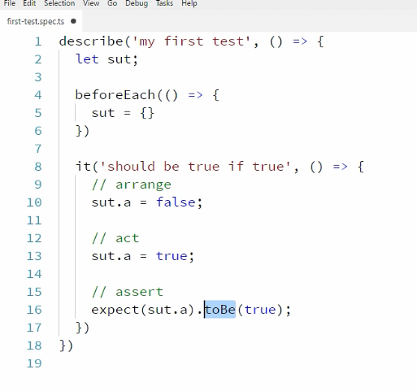

How karma picks .spec files?

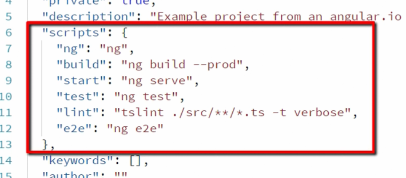

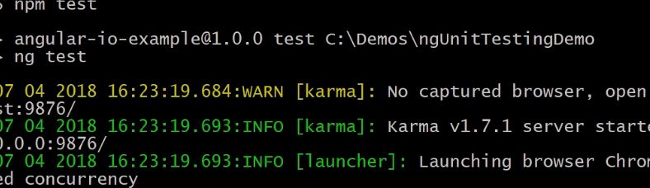

Output

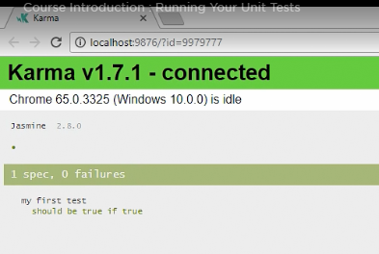

**Testing a pipe**

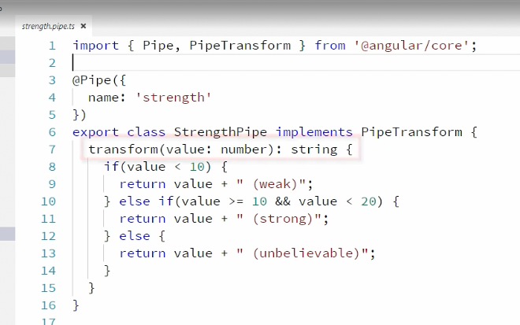

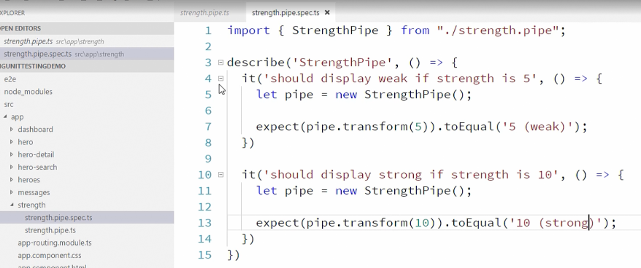

Run ng test

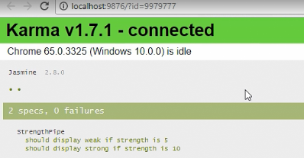

Testing a simple service:

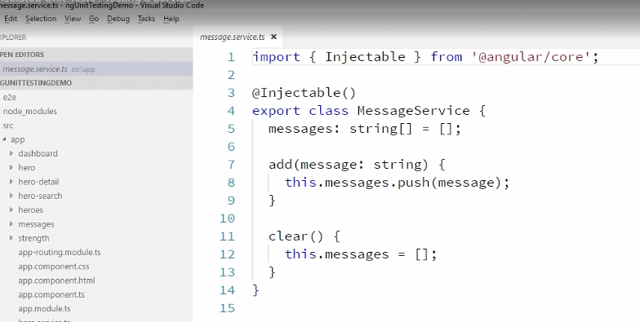

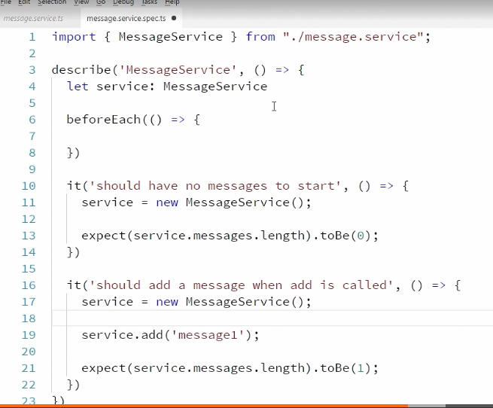

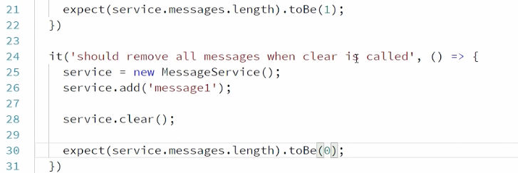

Testing a component :

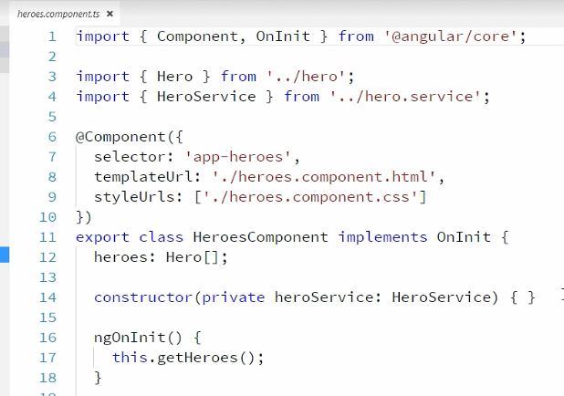

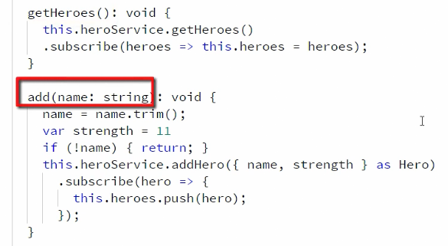

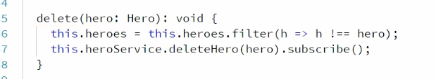

And now the test file

Import { of } from ‘rxjs/observable’ ;

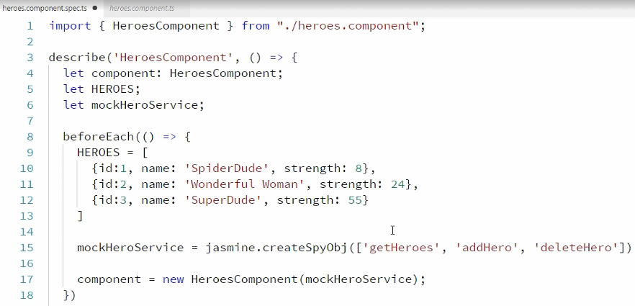

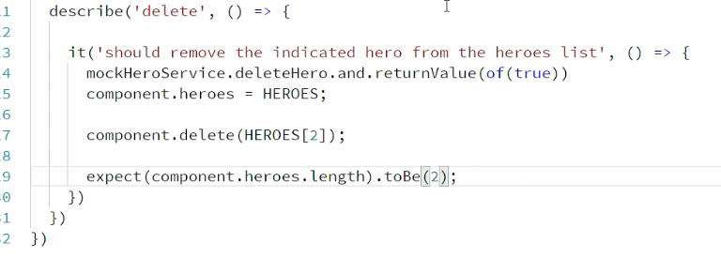

Another scenario is that if we want to check if heroService.deleteHero method is called in the component’s delete method. Below is the test case

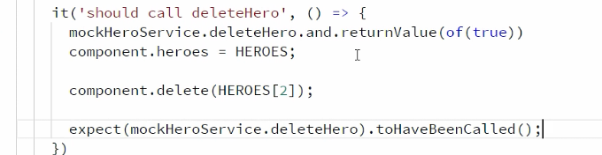

But in the component , delete Service method is called with parameter of type hero

So in this case,

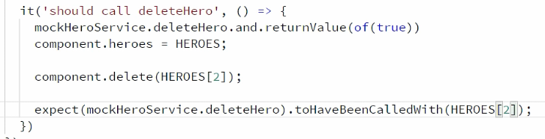

**Shallow integration tests:**

In console, we see following sourcemaps in console often

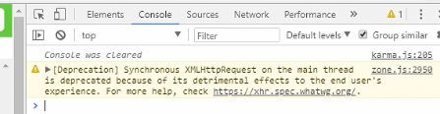

To remove those

Go to package.json and add

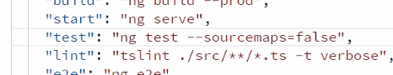

Output of ng test

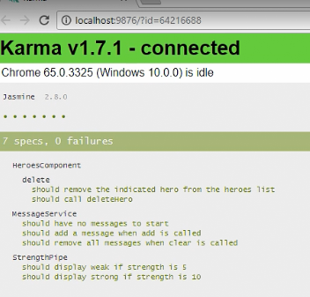

**For shallow integration tests, we use TestBed**

It allows us test the component along with its template.

Hero component

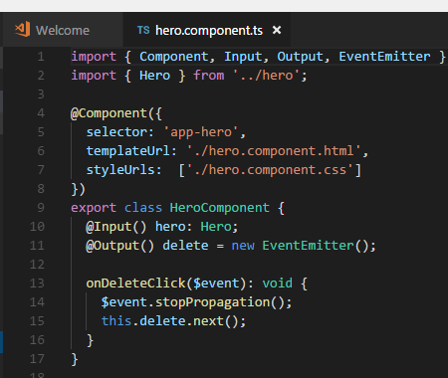

It has input hero which we need to set

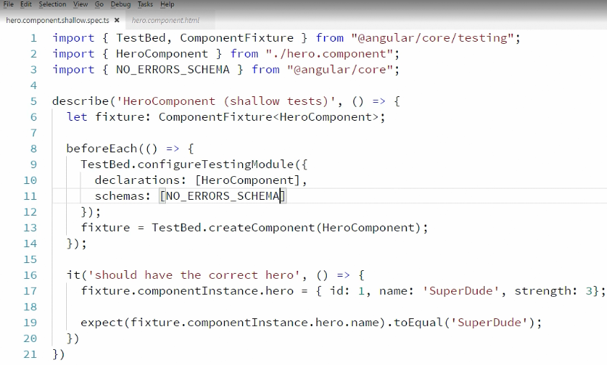

You can notice we have added schemas : NO_ERROR_SCHEMA (from @angular/core) to ignore hero.html file.

But it is not a good practice. Ignore html code scan is incorrect.

For example: User can type <za instead of anchor tag <a

To check a particular template, we can use the below 2 way

1: native element

2: debug element

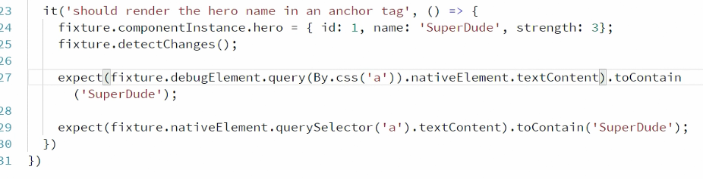

‘By’ is from angular/ platform-browser

Karma status:

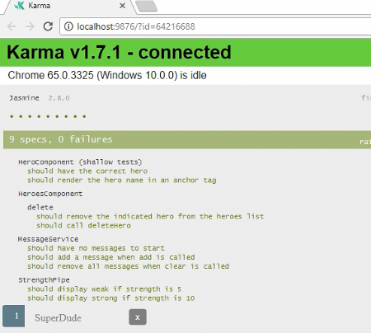

For hero component , there was no provider in the td constructor . Html didn’t have any child component

But in case of Heros.component

We have hero service registered in the constructor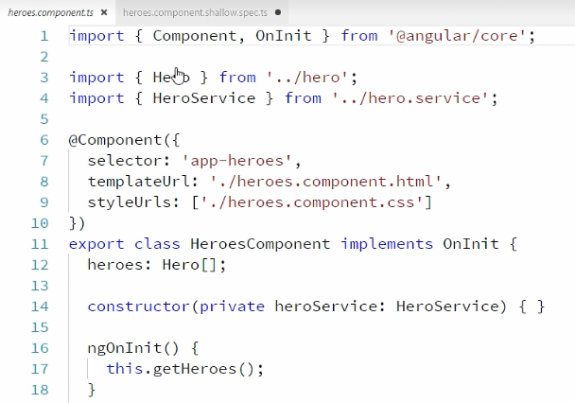

And in heroes.html we have

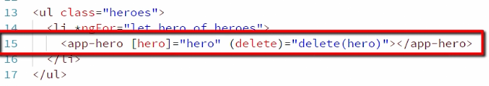

Lets do the test file:

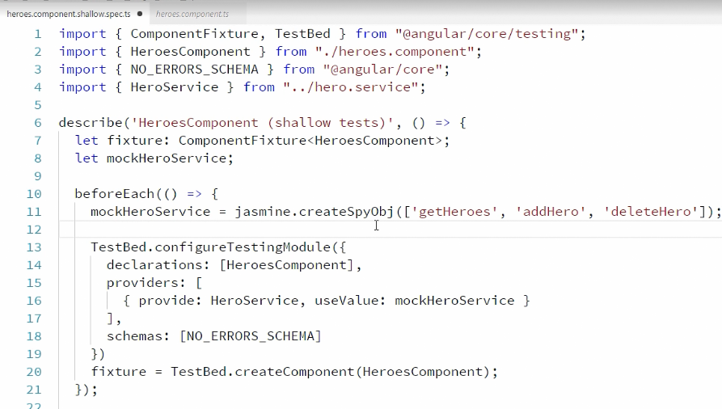

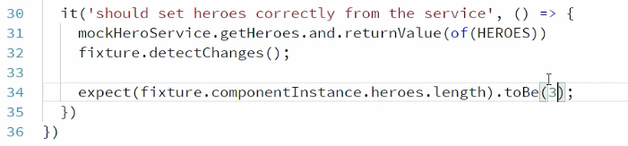

In above example , we have used NO_ERRORS_SCHEMA and avoided html scan.

But inorder to scan, we need to comment this line.

Now in this case , heroes html has app-hero selector tag. That means it has child component .

So we need to mock this component in our case.

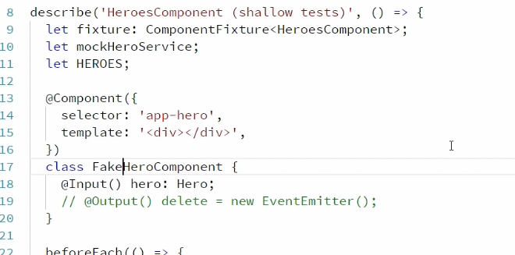

And register in

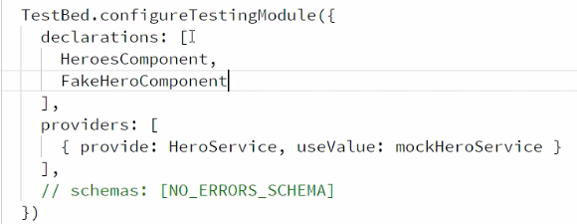

A test case

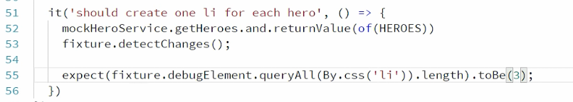

Counts number of li tags in html

**Deep Integration testing:**

Shallow integration tests allow us test ts + DOM

It also allows to provide dependent but fake components just to complete the shallow case. But in deep integration , we are also checking the interactions between components.

In our case, its heroes component + Dom and hero component

Create a file

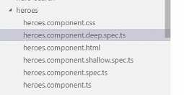

So instead of having fake hero component, we will have real hero component

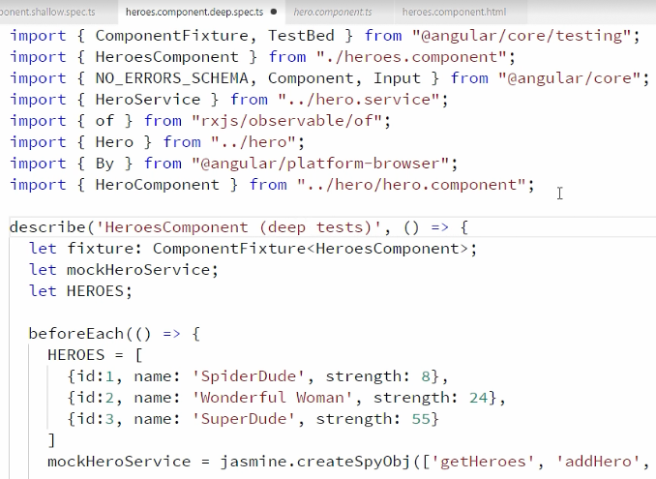



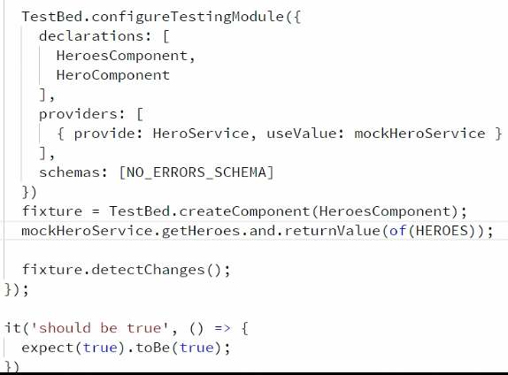



**Finding Elements directive:**

Make some changes in the above file:

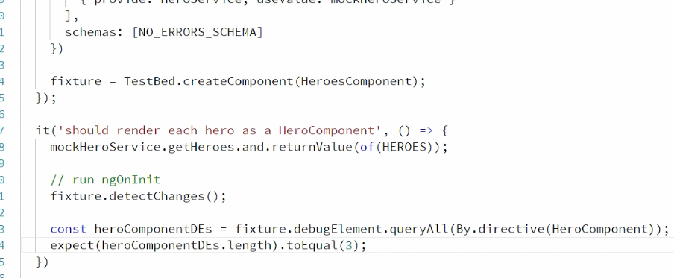

You can have multiple expects

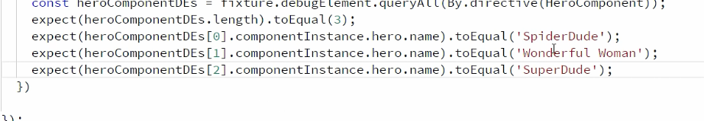

Using loop

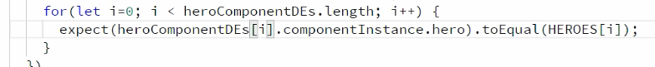

**Integration Testing of services:**

Consider below service

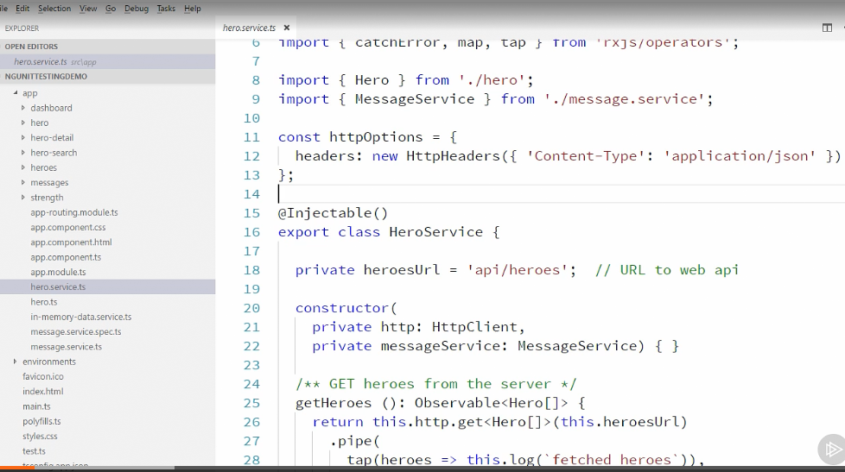

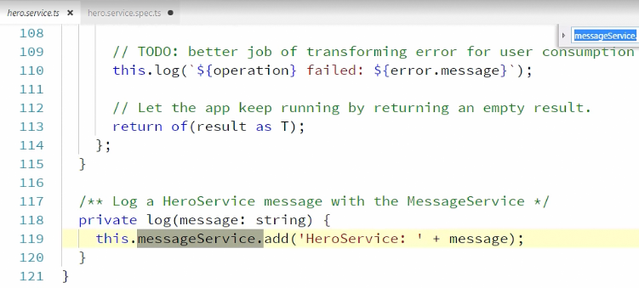

Create below file in app/ folder

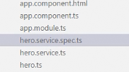

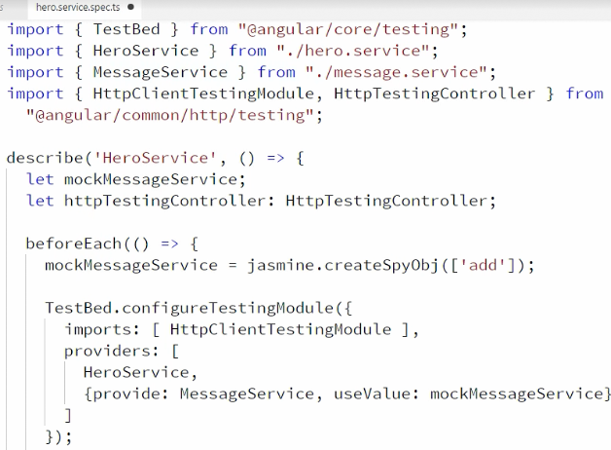

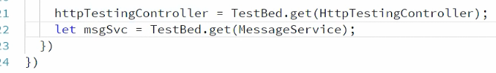

Lets test below method of hero service:

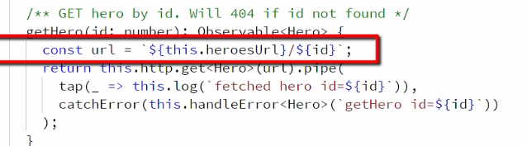

There are 2 ways to test:

1. By using testbed instances:

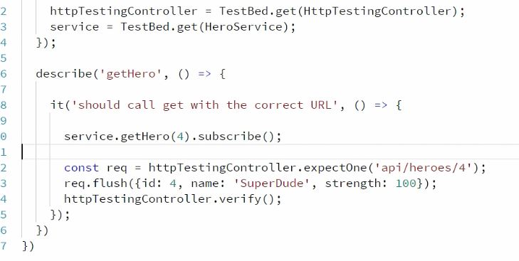

1. By using inject function

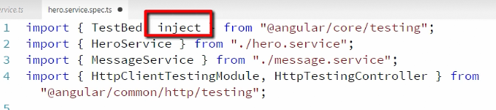

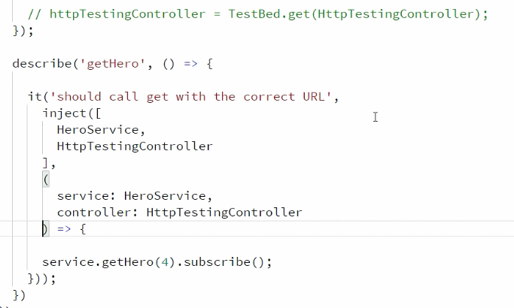

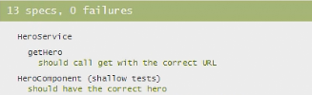

Testing DOM Interaction and Routing Components

In heroes component html

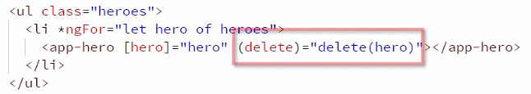

In hero component , we have event propagation

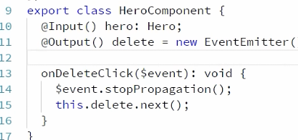

In heroes component we have delete(hero) method

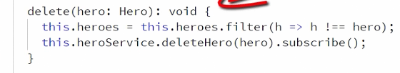

In Heroes spec deep test file, we write our case of delete as below

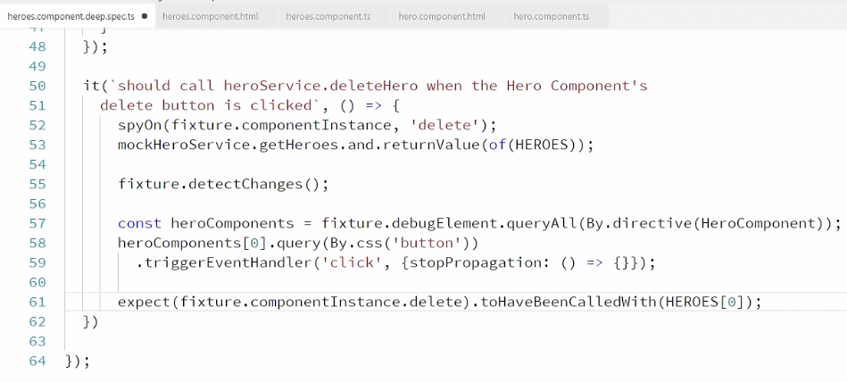

Emitting events from children

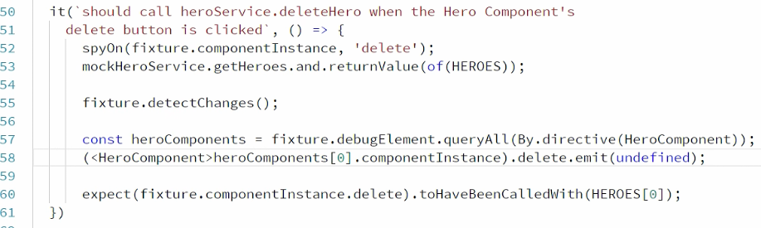

Another way

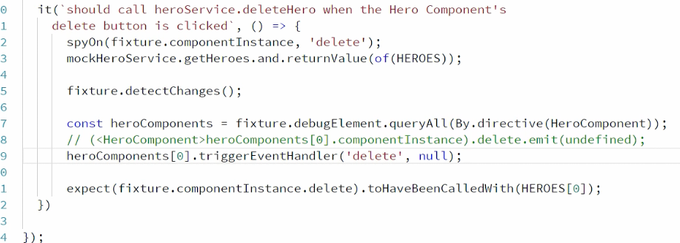

But in the second way , there is no check whether the event actually exist in child component.

**Interacting with Input boxes:**

User enters in input box, and the value gets added into the list . It starts appearing in heroes ->hero component as well

In Hero component we have add method

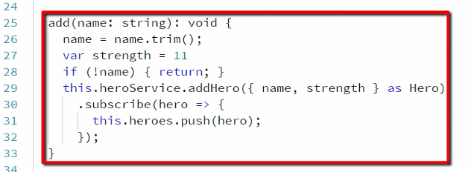

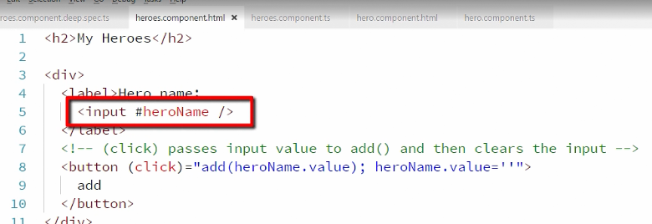

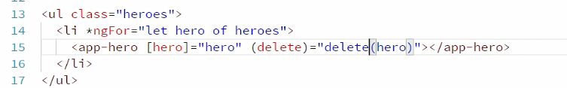

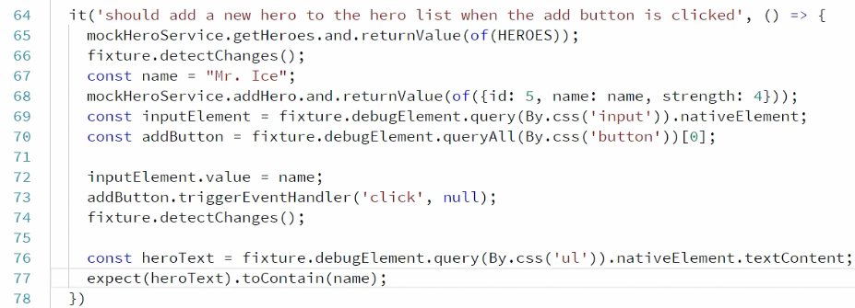

Testing og HeroDetail Component :

Testing the ActivatedRoute :

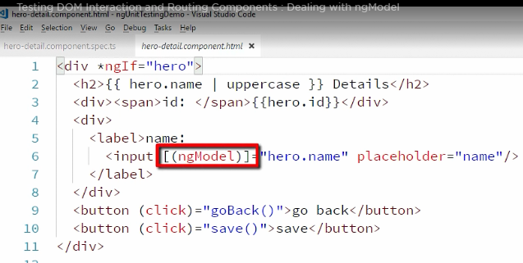

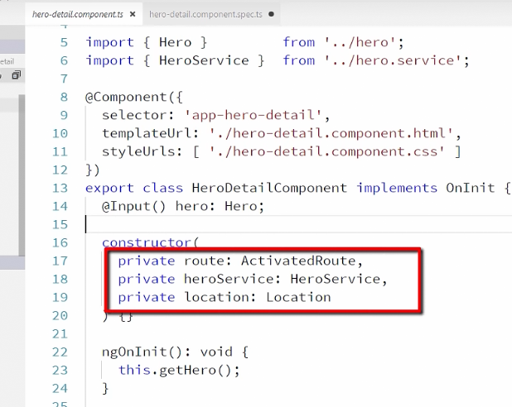

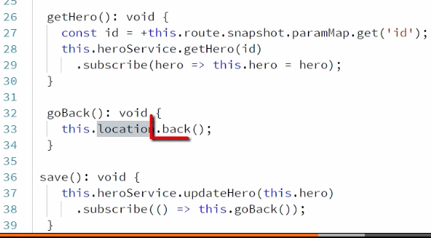

First of all , we mock the 3 injected services

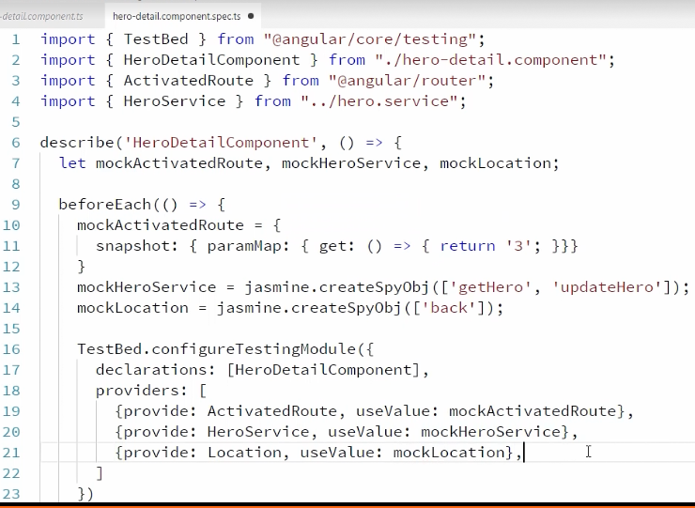



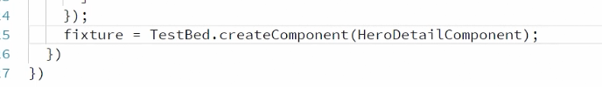

Make some changes as below

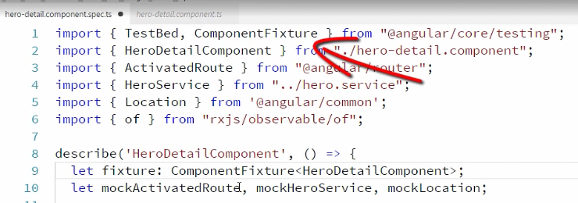

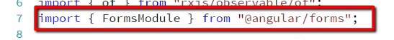

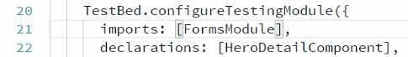

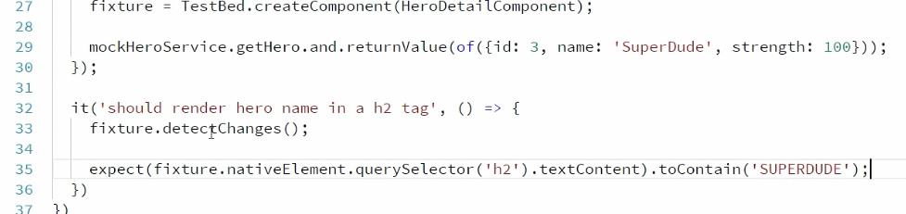

**Lets test router link :**

We will move to heroes.component.deep.spec file where we were facing following issue if we comment NO_ERROR_SCHEMA

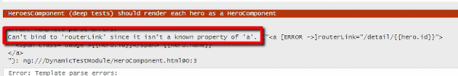

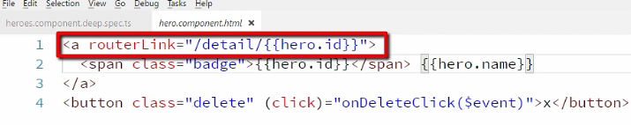

Added a new directive for route

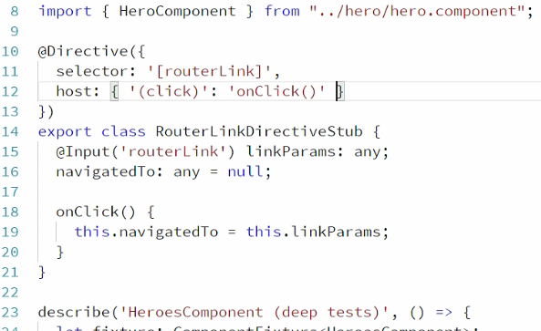

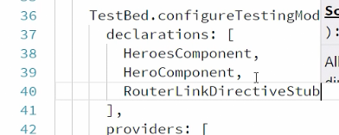

The error is gone.

Lets write 1 more test case there.

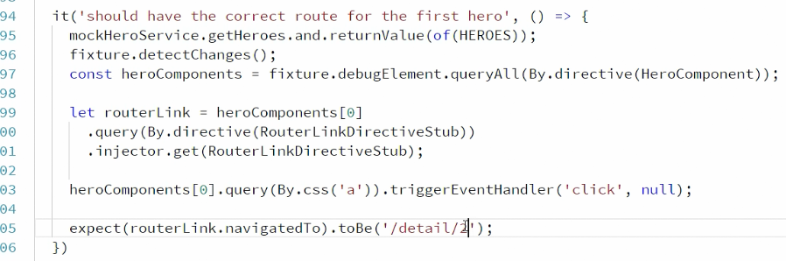

Working with Async code :

We have dependent api calls and it takes time to call the 2nd api. In that case, if we are trying to figure out if the api is called or not. It would give ‘no’ always.

Add folldowing code in hero-detail.component ts

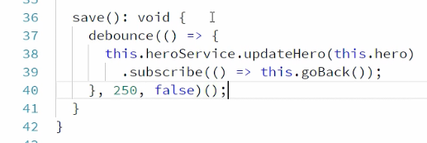

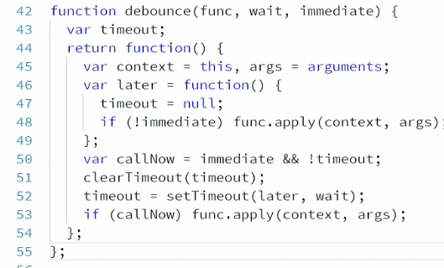

Write a test case:

If we write the following code, it would give us the wrong result

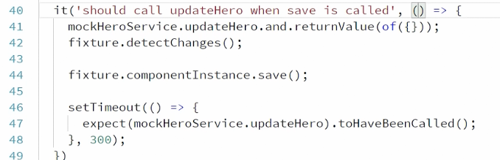

Even though we have expect inside set timeout, it doesn’t wait for it

So we need to add ‘done’

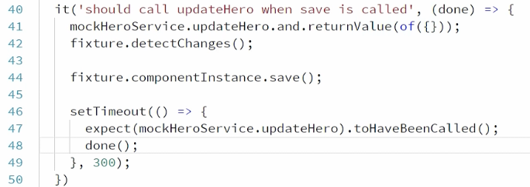

Now we can’t above code when there are 10- 15 expect statement each waiting for 300 ms

Performance would be bad

Solution id fakeAync Helper function from @angular/core/testing

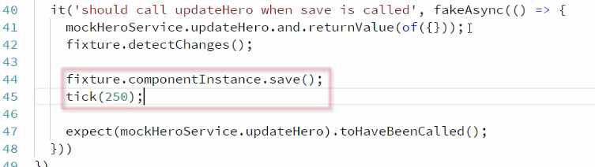

Much simpler solution over ‘tick’ is ‘flush . there we don’t need to provide a wait number such as 250

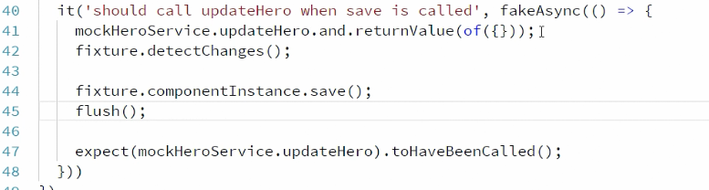

Lets use async function when we have ‘promises’ :

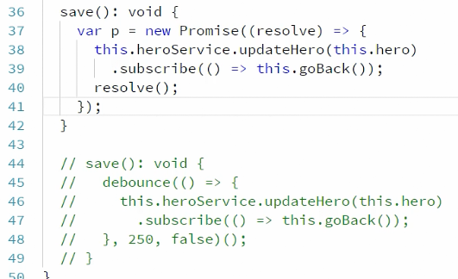

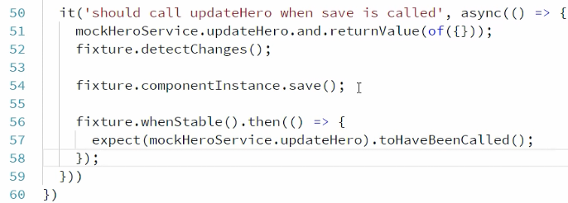

Async only works with ONLY promises ,but fakeAsync works with promises and everything

**Code coverage:**

It allows to see the result graphically

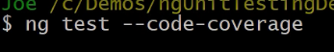

This creates extra folder

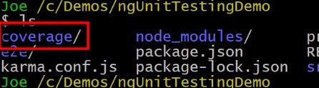

If we open that folder in vs ,

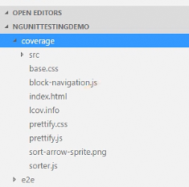

We can open index.html in browser

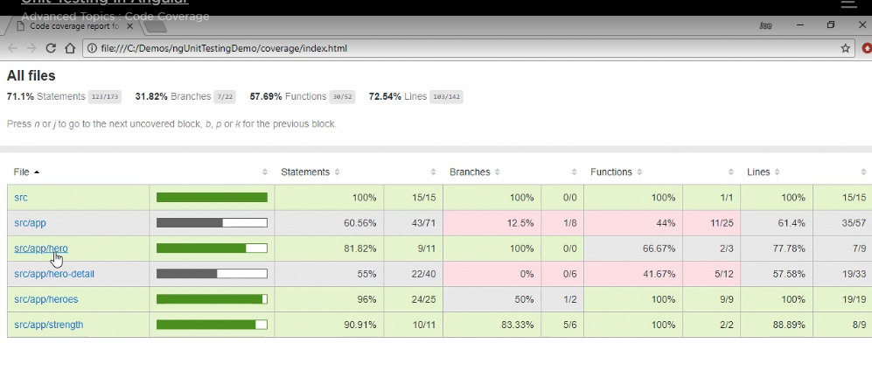

**Finished the course !**

You can use another project similar to hero project as below

